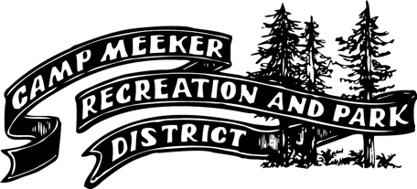

NOTICE OF PUBLIC HEARING

NOTICE IS HEREBY GIVEN that the **Board of Directors of the Camp Meeker Recreation and Park District** will hold a **public hearing on Tuesday, September 16, 2025, at 7:00 p.m.** at **Anderson Hall, 101 Lakeside Avenue, Camp Meeker, CA 95419**, to receive public comment and consider adoption of an updated **Water Code**.

The proposed update consolidates and clarifies District regulations governing water service and system operations. Topics include service connections and permits; billing, payment timelines, and delinquency procedures (including liens and collection on the tax roll); discontinuance of service for non-payment, safety issues, or unauthorized use; meter standards and testing; temporary service; general use and cross-connection/backflow protections; fire protection service; water main extensions and agreements; water conservation requirements; and an updated Schedule of Fees and Charges.

A **copy of the full text** of the proposed Water Code is available for public review during regular business hours at the Camp Meeker Post Office and at Russian River Utility, 7131 Mirabel Road, Forestville, and is also posted on the District’s website at [www.campmeeker.org](http://www.campmeeker.org?utm_source=chatgpt.com).

At the time and place stated above, all interested persons will be given the opportunity to be heard. Written comments may also be submitted to the District prior to the close of the public hearing. Following the hearing, the Board of Directors may adopt the updated Water Code, which will become effective thirty (30) days after adoption.

Dated: September 3, 2025

By Order of the Board of Directors  
**Camp Meeker Recreation and Park District**

*Published on September 5 and 12, 2025, Press Democrat*